Ecosystems: Energy, Producers & Consumers Name: ________________________________
(Read Ch.3.1: pgs. 70-73)

1. Complete the assigned interactive video assigned in Google classroom; The Flow of Energy

2. Infer: Using the following three terms below, number the correct order of energy flow through the ecosystem.
_3_ Heat Energy _1_ Light energy _2_ Chemical energy

3. Using the table below, identify the following terms and their differences

Photosynthesis  Plants use solar energy (light) to make sugars (chemical energy) | Chemosynthesis  Bacteria use inorganic molecules to make sugars (chemical energy)
Autotrophs  Make their own food for themselves and consumers | Heterotrophs  Need to consume food for energy. Cannot produce it
Producers  Produce their own energy. Autotrophs | Consumers  Have to consume energy. Heterotrophs

4. Using Figure 3-2, Define each type of consumer AND give an example of each
- Herbivore: ONLY eat plants example: _Rabbit___
- Carnivore:ONLY eat animals example: _rattlesnake__

- Omnivore:eats BOTH plants and animals example: _kangaroo rat_

- Detritivore:eat detritus (dead organic matter) example: _earthworm__

- Decomposer:Breaks Down organic matter into simpler compounds example: _bacteria & fungi__
- Scavengers: Animals that consume carcasses (dead animals) example: _Vulture_________

5. Infer: Why are decomposers important to the environment?
Help stabilize an ecosystem by returning vital nutrients back into the environment for organisms to use.

6. Which type of consumers directly depends on decomposers? Detritivores

7. What is detritus? Small pieces of dead and decaying plant and animal remains

8. Many organisms do not fit neatly inside the tidy categories ecologists try to place them in. Give an example of when this occurs?
Some carnivores, like hyenas, will scavenge and eat dead animals
Toucans will eat fruit be can also eat small frogs mammals and even baby monkeys

9. Why is it important that consumers have some ‘flexibility’ in their feeding strategies?
It allows animals to be more successful in finding energy for survival. It decreases food as a limiting factor

10. Termites are insects that feed on wood, which contains cellulose. Scientists have observed that some termite species
prefer wood that has been attacked by fungi. Construct an explanation for this observation.
The fungi are decomposers and break down the tough plant fibers (cellulose). This makes it easier for
termites to digest cellulose and obtain energy

11. DRAW a model to illustrate the flow of energy from a non-living source to an herbivore.
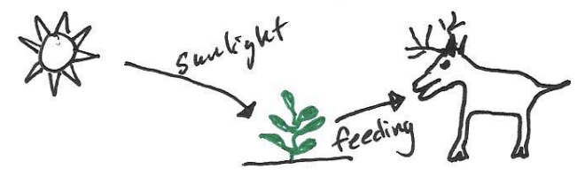

12. Reading Tool: Make Connections; The concept map below shows the relationships between different organisms in the lesson. As you read, complete the concept map using vocabulary terms and other key terms from the lesson. After you have completed the concept map, use a colored pencil to shade all the producers. Then use a different colored pencil to shade all the consumers.
